**Management Plan: Sprint #5**

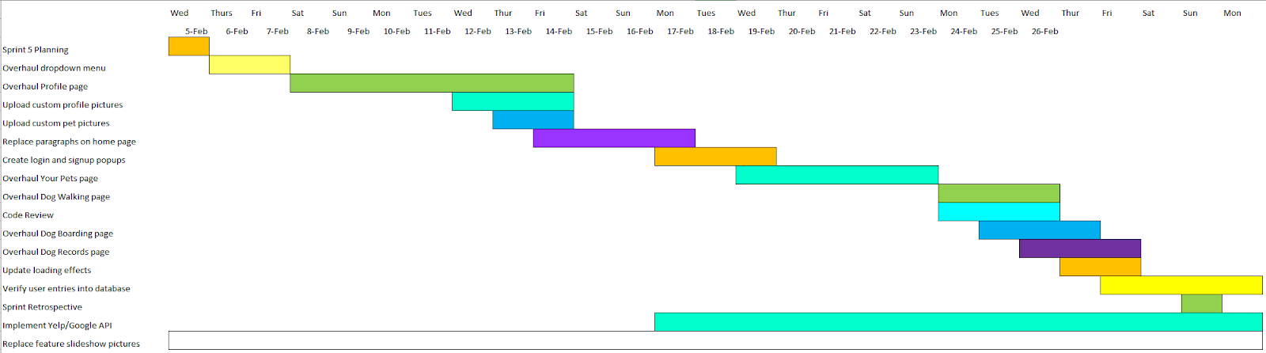**Gnatt Chart:**

The primary goal of this sprint was to continue coding the features pages adding visual appeal and fix some bugs that we found in our code from our previous sprint. We also planned on finding the suitable dataset for our machine learning model and actually start working on it.

**Code Development velocity calculation:**

In this sprint, we had planned to finish 23 points worth tasks and we were able to finish more tasks than we planned this sprint.

**Sprint Retrospective:**We finished all the tasks that were planned for this sprint on time. 23 points were planned in this sprint. We were able to complete those 23 points on time as well as complete 28 extra points. Therefore, in total we completed 51 story points this sprint. Commitment per person every week= 10 hrs. Team commitment per sprint= 10hrs *6 people * 2 weeks = 180hrs. At the beginning of the sprint, we planned more tasks than we thought we would accomplish in one sprint. We expanded our hours worked and we presented later, so we had time to add more user stories to this sprint. This sprint was the most productive by far. In the future, we could assign more tasks to each sprint. The User stories with highest priorities were decided based on which core features were missing or severely lacking. There are 2 user stories in progress totaling 10 points. There is 1 user story in the backlog. The burndown chart didn’t exactly look linear. Progress started slow as we worked on large tasks. But, during the second half of the sprint, we rapidly completed user stories. Many new features will require user feedback. Machine learning will become more of a focus in the next sprint.